`
Name: Suraj Tripathi Class: MCADS11 Roll No: 1250259062

MongoDB Assignment
Data Collections (data sets) Assumed:
- students
- faculty
- courses
- enrollments
- Activities
Simple Steps to Create Database & Collection in MongoDB Compass Step 1: Open & Connect
  - Launch MongoDB Compass
  - Enter connection string: mongodb://localhost:27017
  - Click Save & Connect
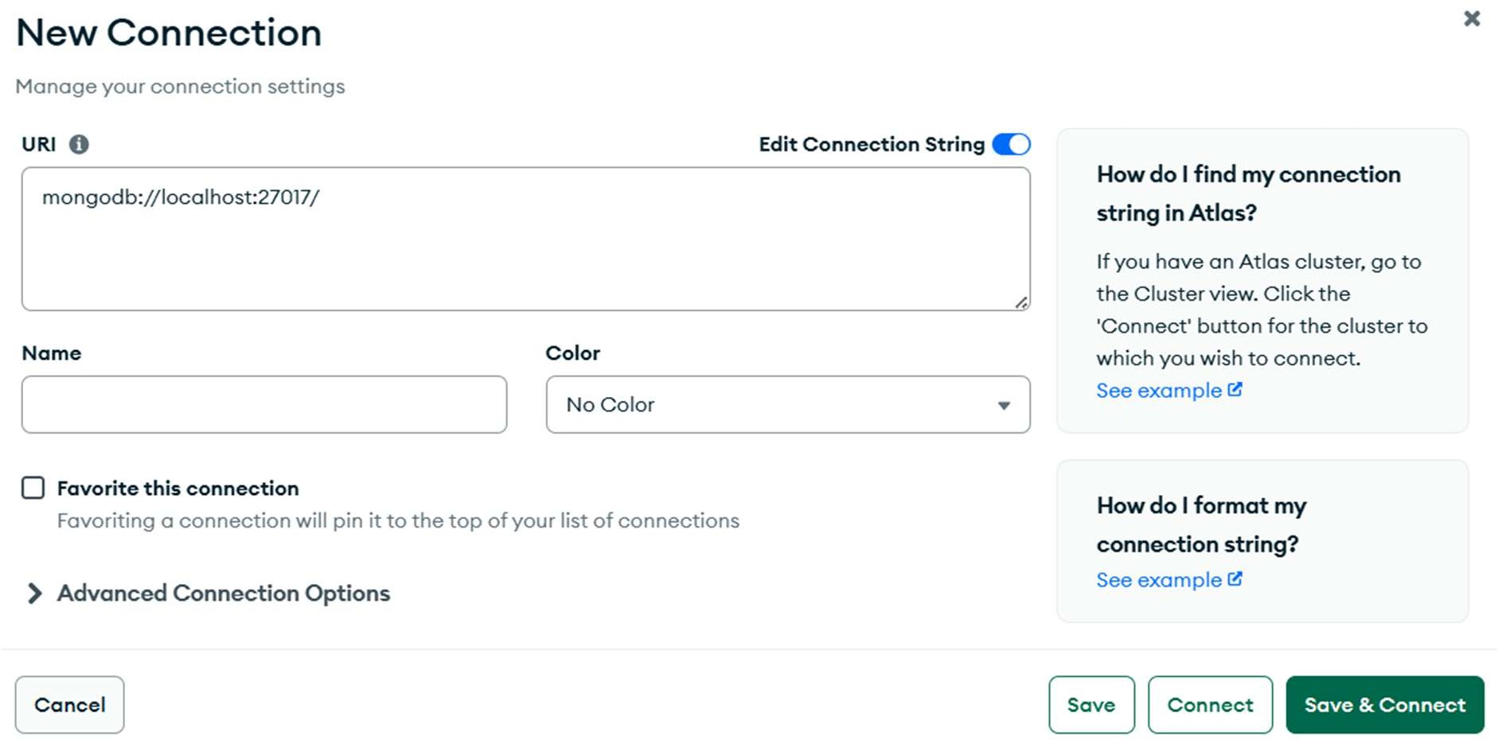
Step 2: Create Database
  - In left sidebar, click + next to "Databases"
  - Database Name: Mongo_assignment
  - Collection Name: courses
  - Click "Create Database"

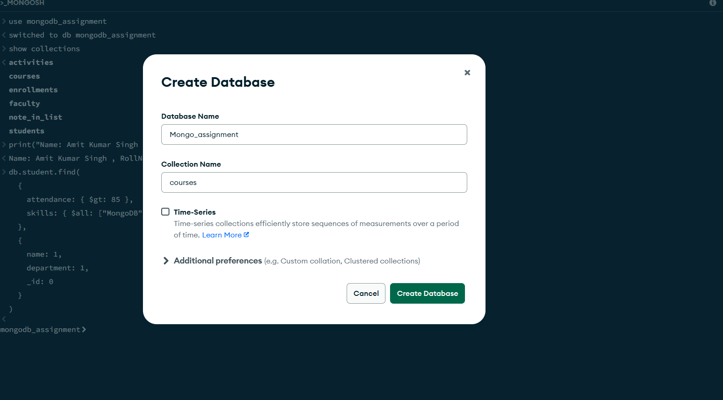

Step 3: Verify Creation
  - New database appears in left sidebar
  - Click it to expand → see your collection
  - 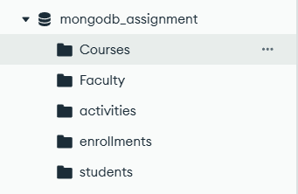

Step 4: Add Sample Document
  - Click "Add Data" → "Insert Document"
  - Add JSON

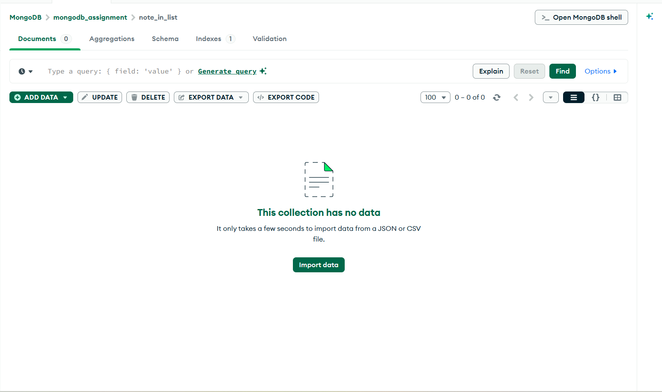

Write a Query for Each Question
- Complex Filters & Projections
Question 1. List the names and departments of students who have more than 85% attendance and are skilled in both "MongoDB" and "Python".

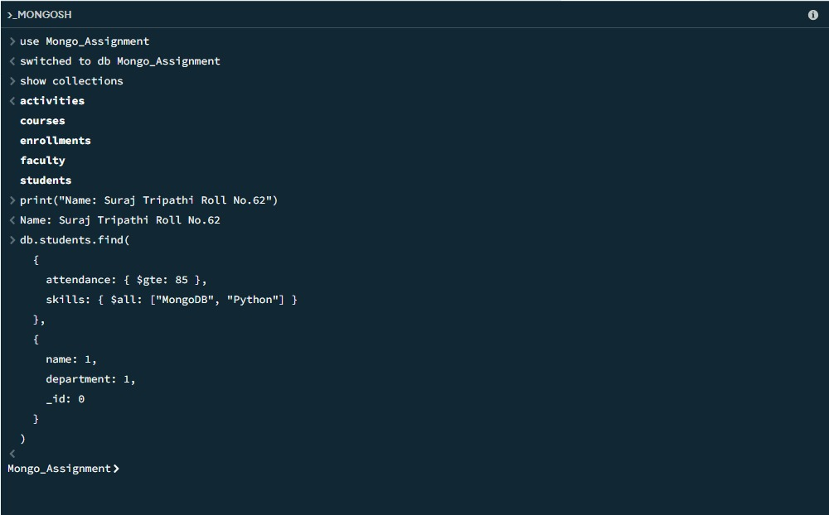

No output means no students match both criteria in your data. Here's why and how to debug.

Question 2. Show all faculty who are teaching more than 2 courses. Display their names and the total number of courses they teach.
Input:

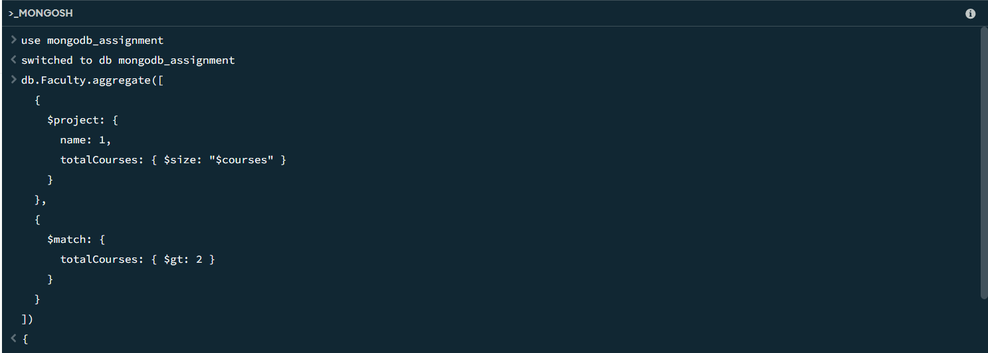
Output:

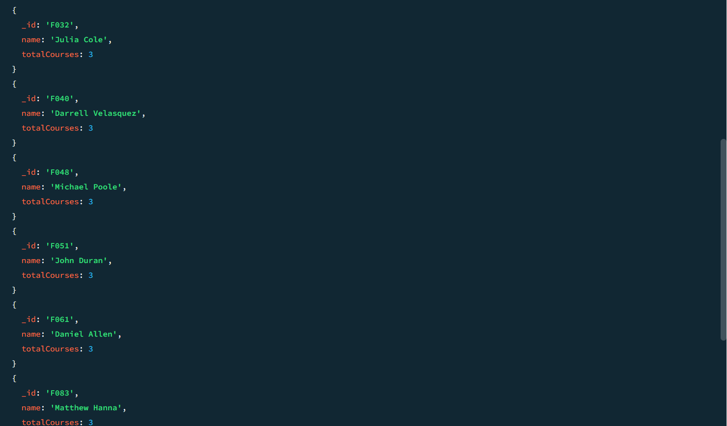

- Joins ($lookup) and Aggregations
Question 3. Write a query to show each student’s name along with the course titles they are enrolled in (use $lookup between enrollments, students, and courses).
Input:
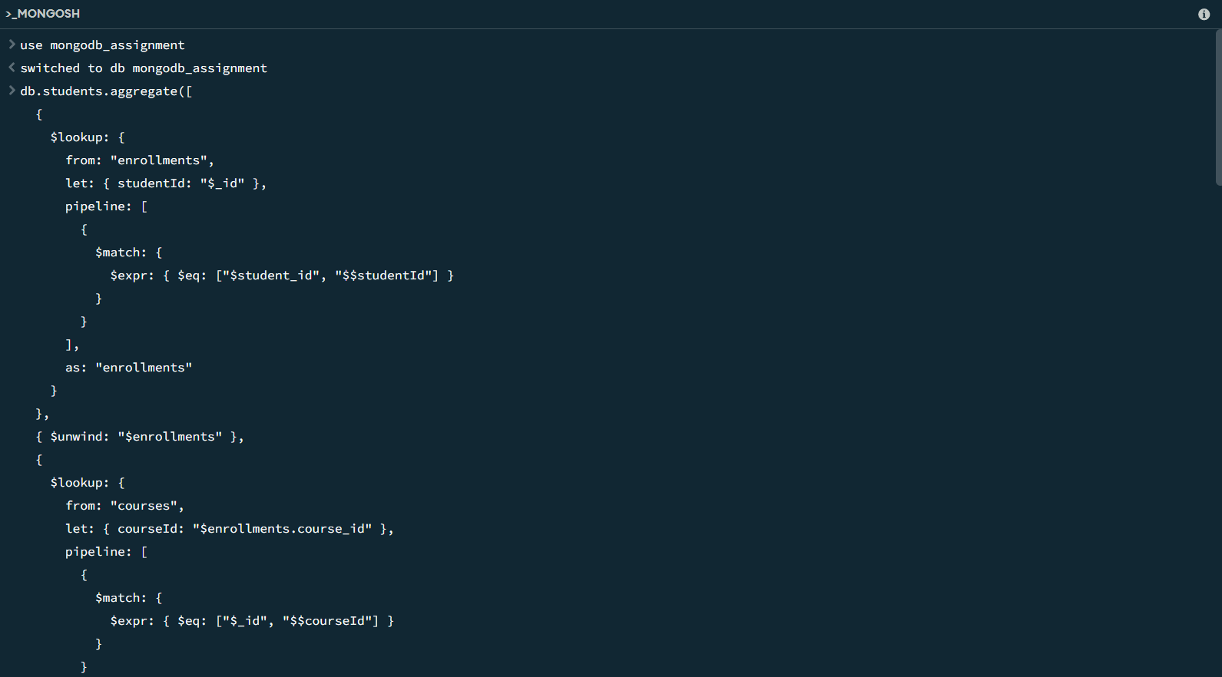

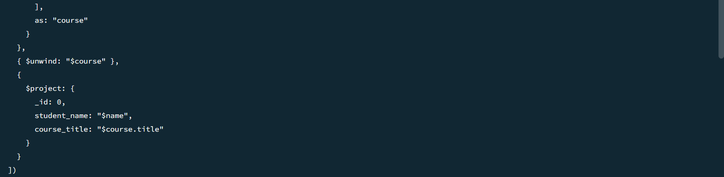

Output:
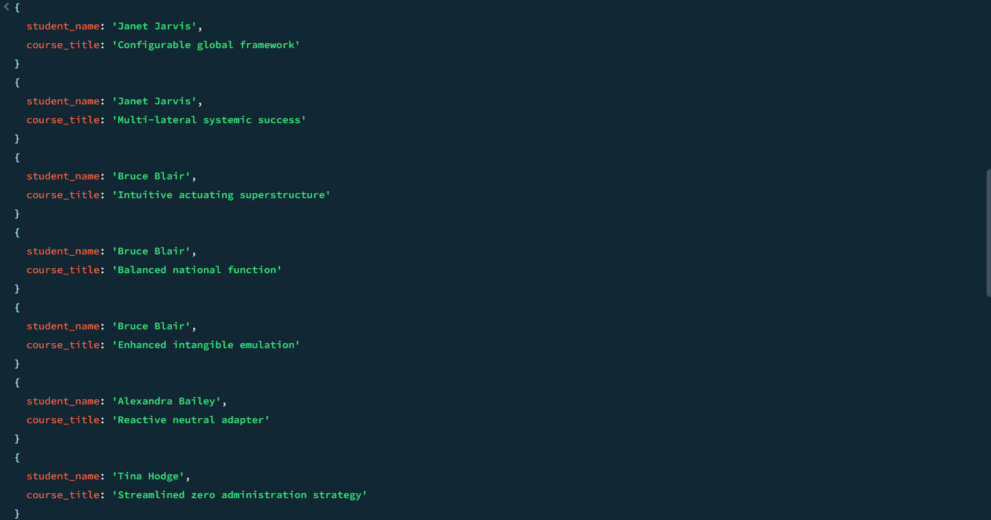
Question 4. For each course, display the course title, number of students enrolled, and average marks (use $group).
Input
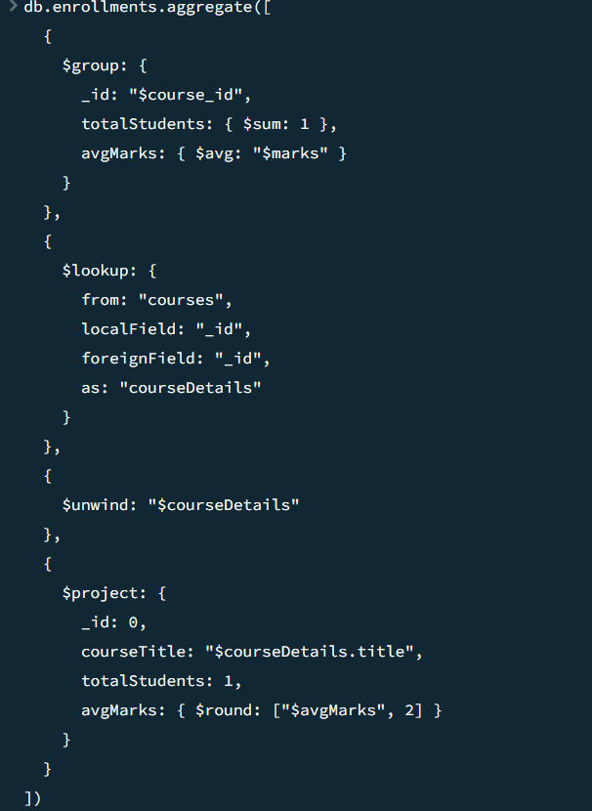

Output:
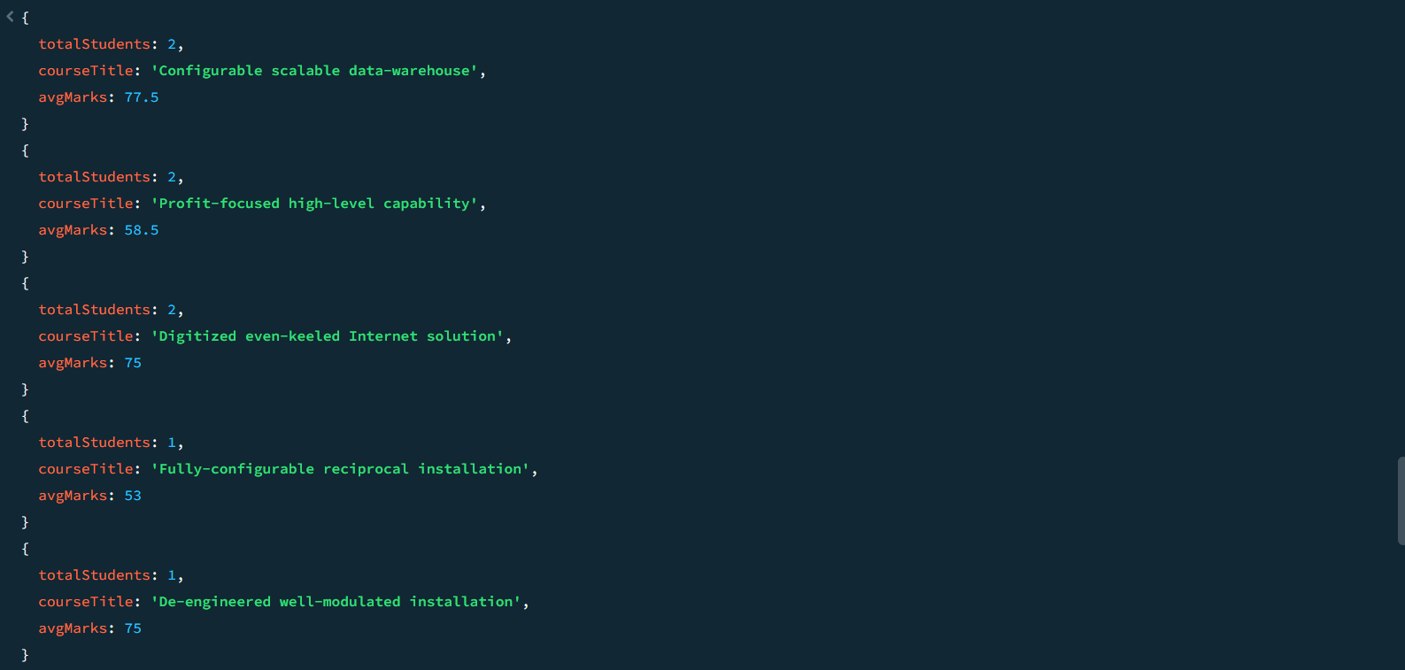

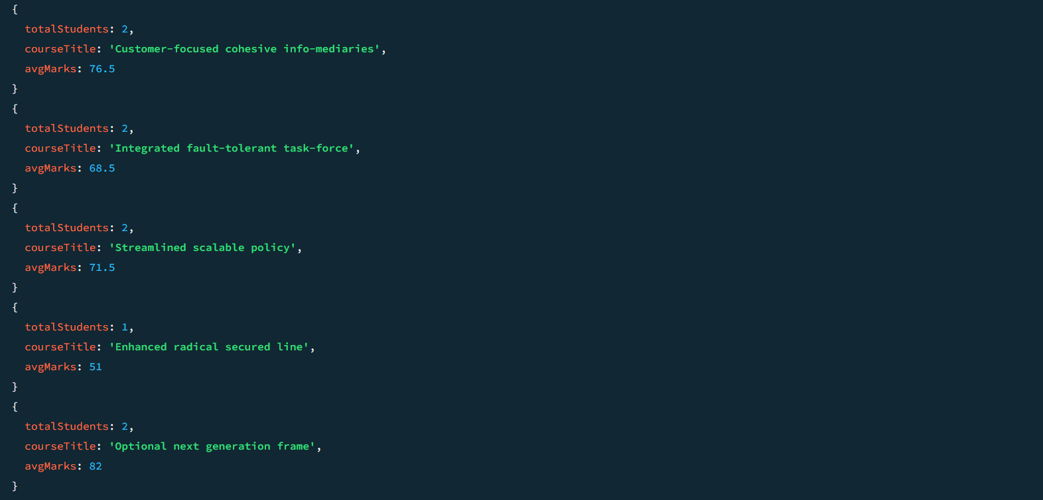

- Grouping, Sorting, and Limiting
Question 5. Find the top 3 students with the highest average marks across all enrolled courses.
Input:
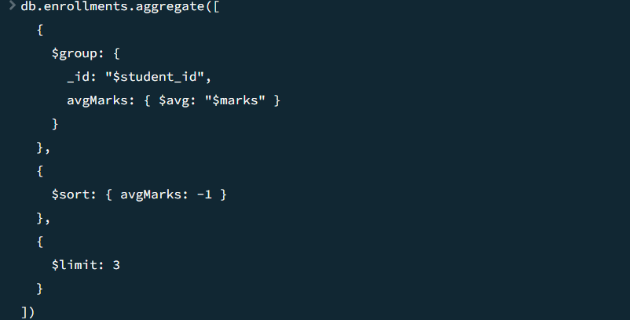
Output:
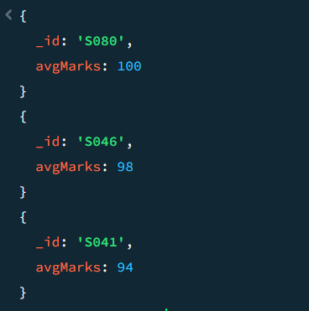

Question 6. Count how many students are in each department. Display the department with the highest number of students.
Input and Output:

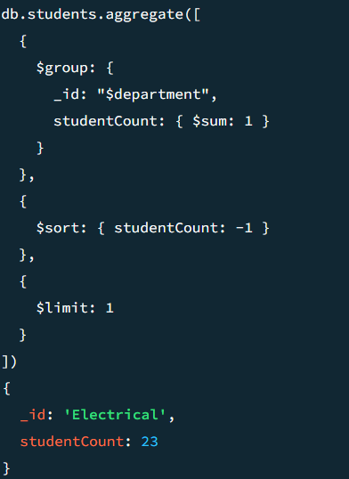

- Update, Upsert, and Delete
Question 7. Update attendance to 100% for all students who won any "Hackathon".
Input and Output:
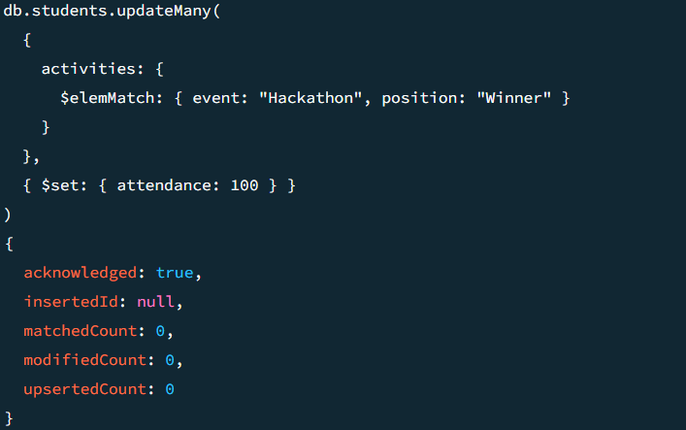

Question 8. Delete all student activity records where the activity year is before 2022.
Input and Output:
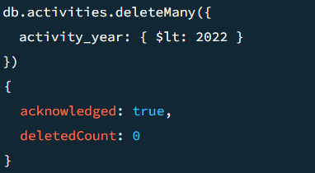

Question 9. Upsert a course record for "Data Structures" with ID "C150" and credits 4—if it doesn’t exist, insert it; otherwise update its title to "Advanced Data Structures".
Input and output:

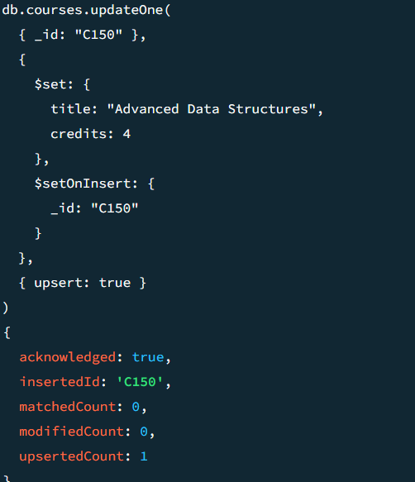

- Array & Operator Usage
Question 10. Find all students who have "Python" as a skill but not "C++".
Input:
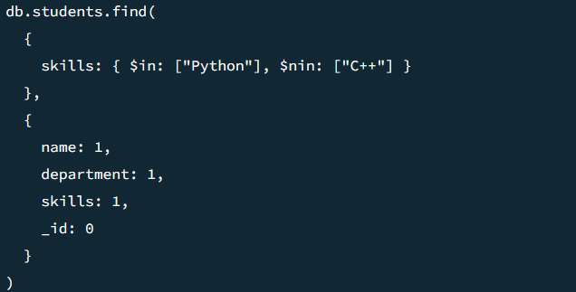

Output:
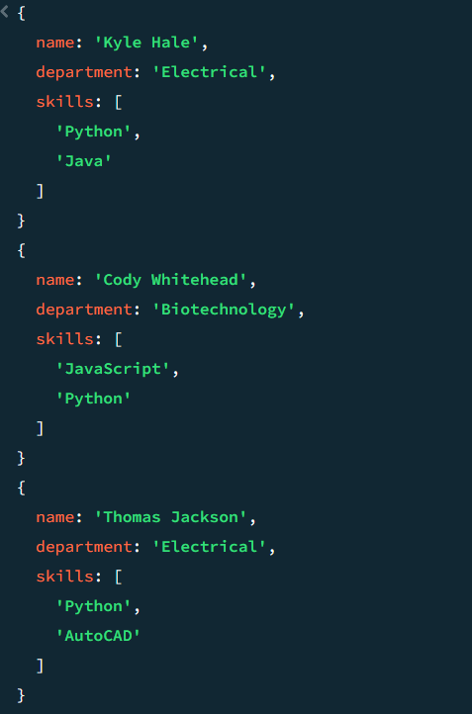

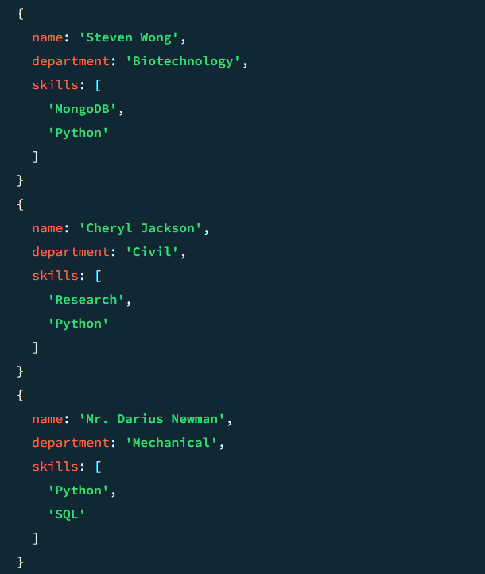

Question 11. Return names of students who participated in "Seminar" and "Hackathon" both.
Input:

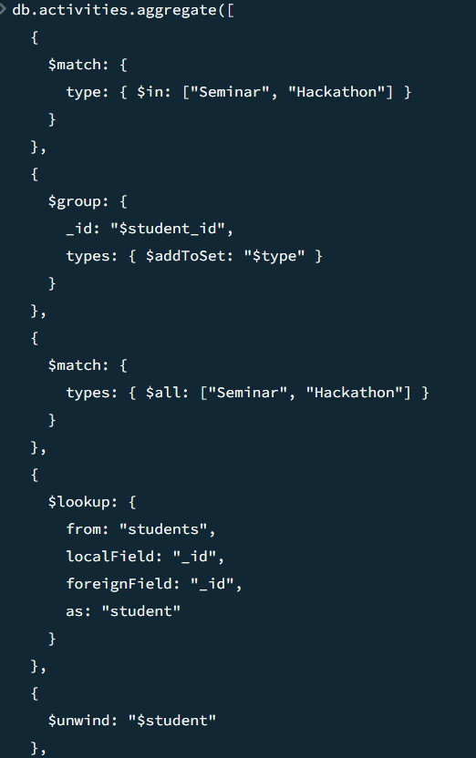
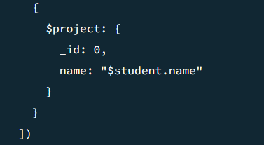
Output:
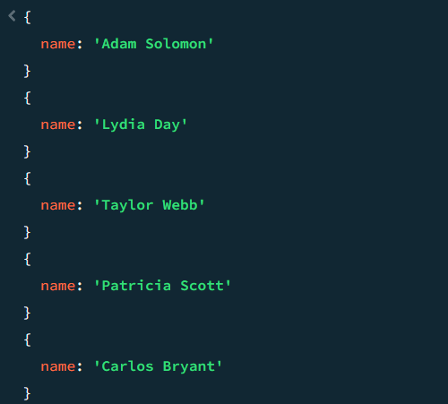

- Subdocuments and Nested Conditions
Question 12. Find students who scored more than 80 in "Web Development" only if they belong to the "Computer Science" department.
Input & Output:
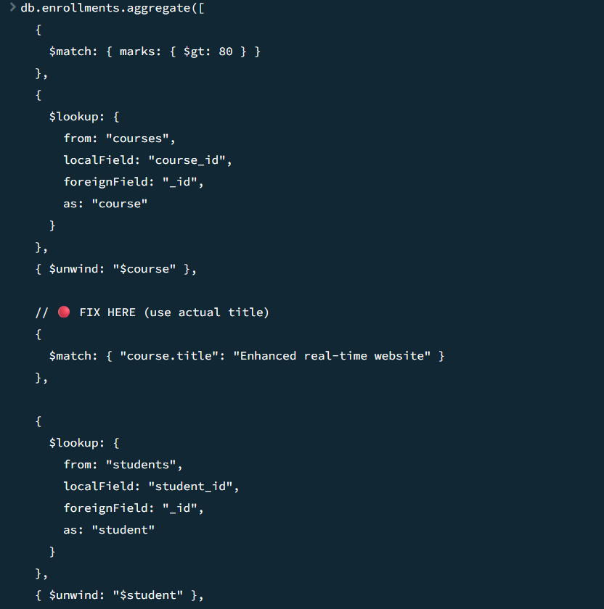

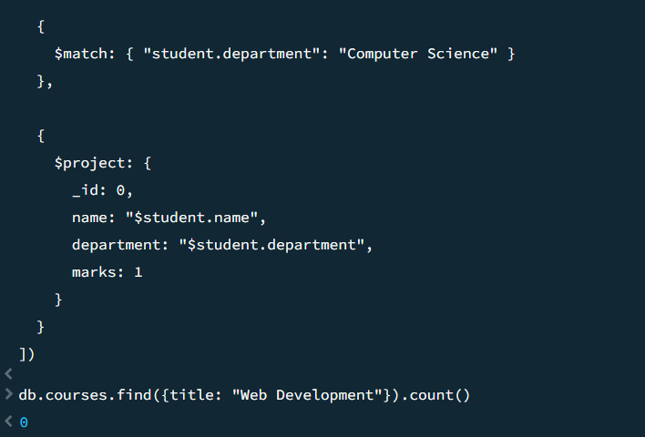

- Advanced Aggregation (Challenge Level)
Question13. For each faculty member, list the names of all students enrolled in their courses along with average marks per student per faculty.
Input and

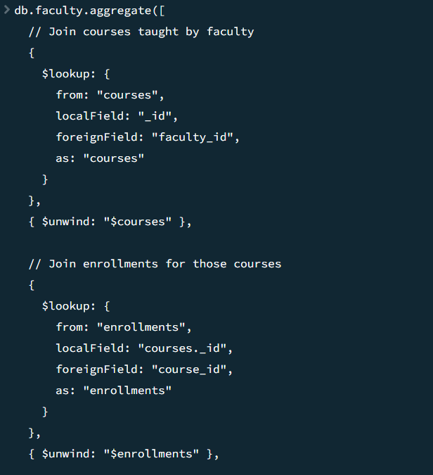

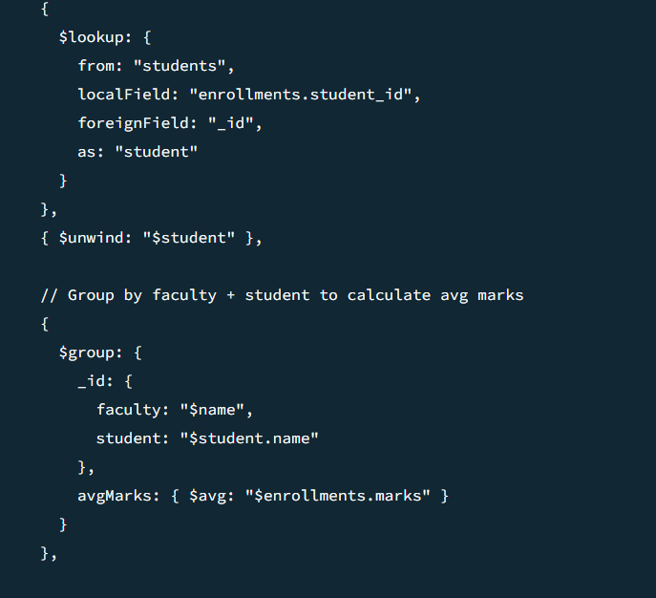

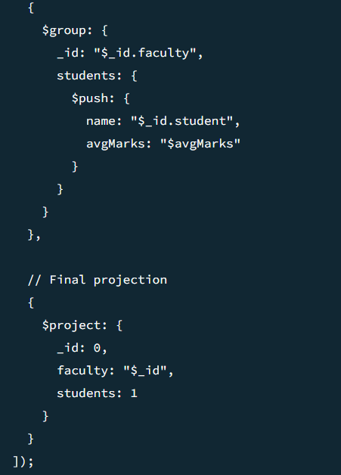

Output:
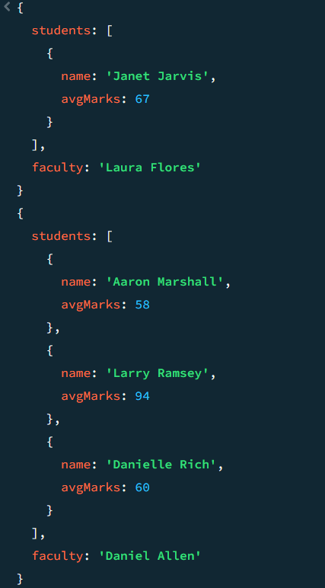

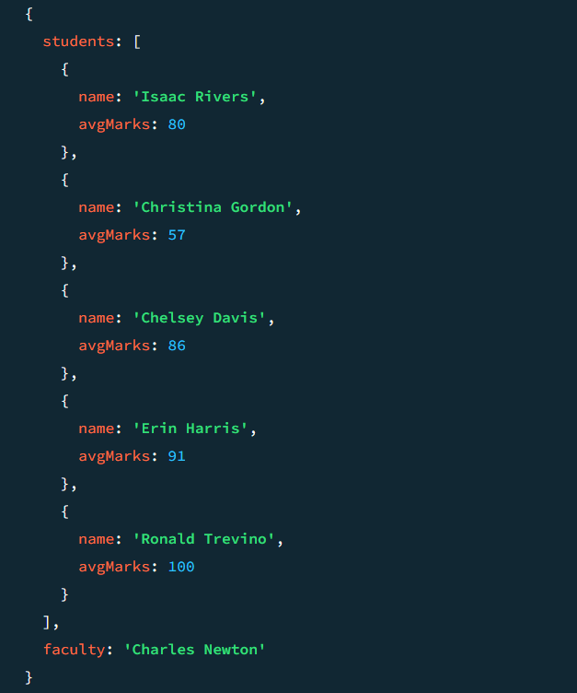
Question14. Show the most popular activity type (e.g., Hackathon, Seminar, etc.) by number of student participants.
Input and Output:
